The edit profile form is susceptible to XSS.

Payload:<img src=”” onerror=alert(1)>

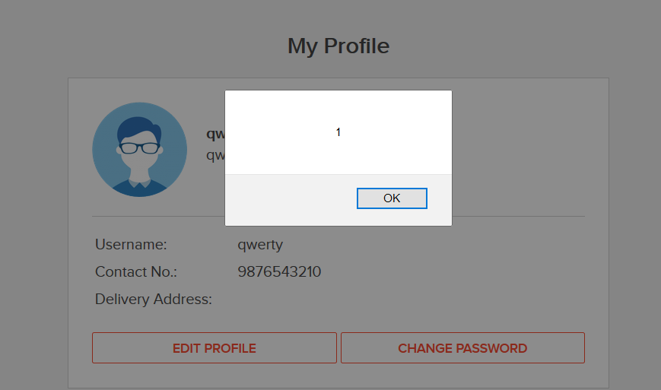

The product review field can be compromised due to XSS.

